**RAID (redundant array of independent disks)**

RAID (redundant array of independent disks) is a way of storing the same data in different places on multiple [hard disks](https://searchstorage.techtarget.com/definition/hard-disk) or solid-state drives to protect data in the case of a drive failure. There are different RAID levels, however, and not all have the goal of providing [redundancy](https://whatis.techtarget.com/definition/redundancy).

**Disk mirroring and disk striping can also be combined in a RAID array.**

In a single-user system where large [records](https://searchoracle.techtarget.com/definition/record) are stored, the stripes are typically set up to be small (perhaps 512 bytes) so that a single record spans all the disks and can be accessed quickly by reading all the disks at the same time.

In a multi-user system, better performance requires a stripe wide enough to hold the typical or maximum size record, allowing overlapped disk I/O across drives.

### RAID levels

Raid devices will make use of different versions, called levels. The original paper that coined the term and developed the RAID setup concept defined six levels of RAID -- 0 through 5. This numbered system enabled those in IT to differentiate RAID versions.

**Data striping**  :

In [computer data storage](https://en.wikipedia.org/wiki/Computer_data_storage), **data striping** is the technique of segmenting logically sequential data, such as a file, so that consecutive segments are stored on different physical storage devices.

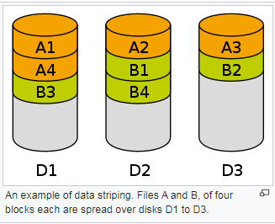

An example of data striping. Files A and B, of four blocks each are spread over disks D1 to D3.

### Fault tolerance is the property that enables a [system](https://en.wikipedia.org/wiki/System) to continue operating properly in the event of the failure of (or one or more faults within) some of its components. If its operating quality decreases at all, the decrease is proportional to the severity of the failure, as compared to a naively designed system, in which even a small failure can cause total breakdown. Fault tolerance is particularly sought after in [high-availability](https://en.wikipedia.org/wiki/High-availability) or [life-critical systems](https://en.wikipedia.org/wiki/Life-critical_system). The ability of maintaining functionality when portions of a system break down is referred to as graceful degradation.[[1]](https://en.wikipedia.org/wiki/Fault_tolerance#cite_note-1)

**Disk mirroring** is the [replication](https://en.wikipedia.org/wiki/Replication_(computing)) of [logical disk](https://en.wikipedia.org/wiki/Logical_disk) volumes onto separate physical [hard disks](https://en.wikipedia.org/wiki/Hard_disk) in [real time](https://en.wikipedia.org/wiki/Real-time_computing) to ensure [continuous availability](https://en.wikipedia.org/wiki/Continuous_availability). It is most commonly used in [RAID 1](https://en.wikipedia.org/wiki/RAID_1). A **mirrored volume** is a complete logical representation of separate volume copies.

**ECC (either "error correction [or correcting] code" or "error checking and correcting")** allows data that is being read or transmitted to be checked for errors and, when necessary, corrected [on the fly](https://whatis.techtarget.com/definition/on-the-fly). It differs from [parity](https://searchstorage.techtarget.com/definition/parity)-checking in that errors are not only detected but also corrected. ECC is increasingly being designed into data storage and transmission hardware as data rates (and therefore error rates) increase

A **parity bit**, or check **bit**, is a **bit** added to a string of binary code to ensure that the total number of 1-**bits** in the string is even or odd. **Parity bits** are used as the simplest form of error detecting code. There are two variants of **parity bits**: even **parity bit** and odd **parity bit**.

**the quality or state of being equal or equivalent**

### Standard RAID levels

[**RAID 0**](https://searchstorage.techtarget.com/definition/RAID-0-disk-striping)**.** This configuration has striping, but no redundancy of data. It offers the best performance, but it does not provide fault tolerance.

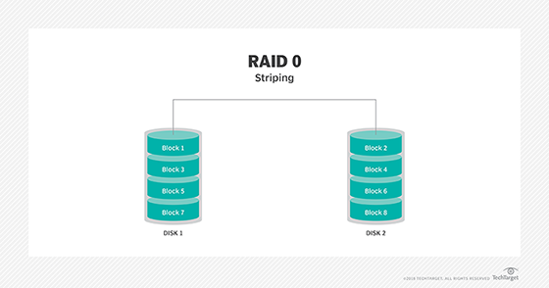

[**RAID 1**](https://searchstorage.techtarget.com/definition/disk-mirroring)**.** Also known as disk mirroring, this configuration consists of at least two drives that duplicate the storage of data. There is no striping. Read performance is improved since either disk can be read at the same time. Write performance is the same as for single disk storage.

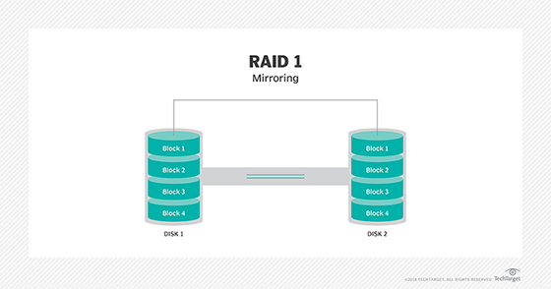

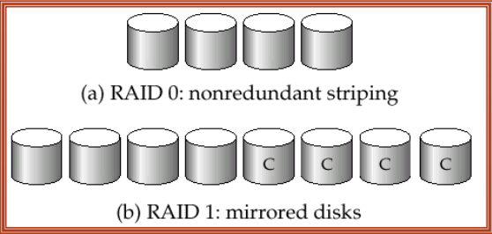

[**RAID 2**](https://searchstorage.techtarget.com/definition/RAID-2-redundant-array-of-independent-disks)**.** This configuration uses striping across disks, with some disks storing error checking and correcting ([ECC](https://searchnetworking.techtarget.com/definition/ECC)) information. RAID 2 also uses a dedicated Hamming code parity; a linear form of error correction code. RAID 2 has no advantage over RAID 3 and is no longer used.

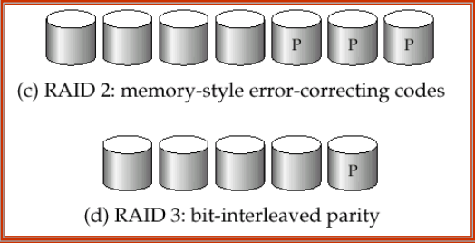

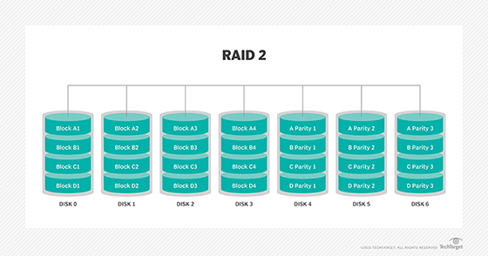

[**RAID 3**](https://searchstorage.techtarget.com/definition/RAID-3-redundant-array-of-independent-disks)**.** This technique uses striping and dedicates one drive to storing [parity](https://searchstorage.techtarget.com/definition/parity) information. The embedded ECC information is used to detect errors. [Data recovery](https://searchdisasterrecovery.techtarget.com/definition/data-recovery) is accomplished by calculating the exclusive information recorded on the other drives. Since an I/O operation addresses all the drives at the same time, RAID 3 cannot overlap I/O. For this reason, RAID 3 is best for single-user systems with long record applications.

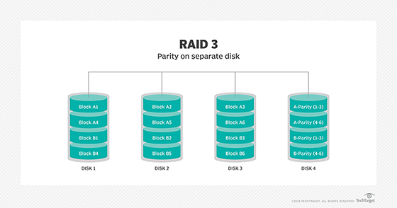

[**RAID 4**](https://searchstorage.techtarget.com/definition/RAID-4-redundant-array-of-independent-disks)**.** This level uses large stripes, which means a user can read records from any single drive. Overlapped I/O can then be used for read operations. Since all write operations are required to update the parity drive, no I/O overlapping is possible.

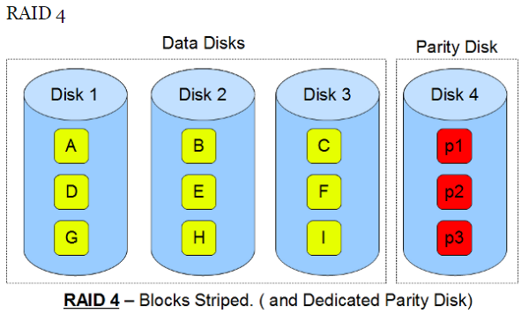

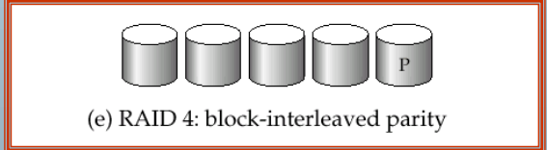

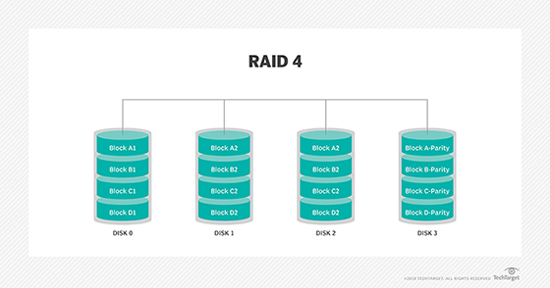

[**RAID 5**](https://searchstorage.techtarget.com/definition/RAID-5-redundant-array-of-independent-disks)**.**This level is based on parity [block](https://searchsqlserver.techtarget.com/definition/block)-level striping. The parity information is striped across each drive, enabling the array to function even if one drive were to fail. The array's architecture allows read and write operations to span multiple drives -- resulting in performance better than that of a single drive, but not as high as that of a RAID 0 array. RAID 5 requires at least three disks, but it is often recommended to use at least five disks for performance reasons.

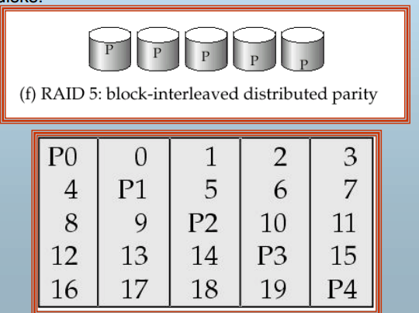

RAID 5 arrays are generally considered to be a poor choice for use on write-intensive systems because of the performance impact associated with writing parity data. When a disk fails, it can take a long time to rebuild a RAID 5 array.

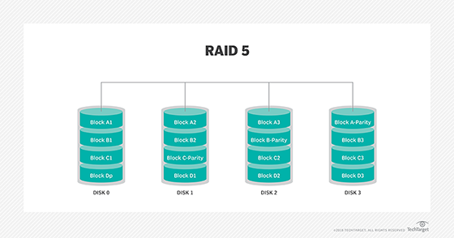

[**RAID 6**](https://searchstorage.techtarget.com/definition/RAID-6-redundant-array-of-independent-disks)**.** This technique is similar to RAID 5, but it includes a second parity scheme distributed across the drives in the array. The use of additional parity enables the array to continue to function even if two disks fail simultaneously. However, this extra protection comes at a cost. RAID 6 arrays often have slower write performance than RAID 5 arrays.

